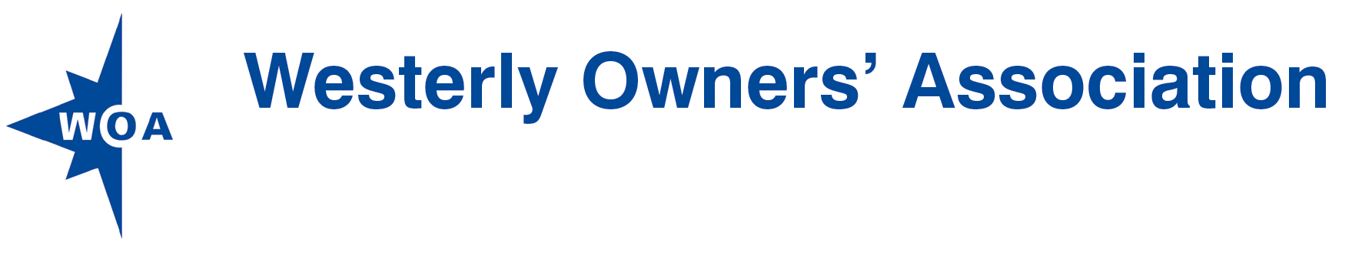

How to order WOA Polo shirts with your boat name

£11.25 each+pp
WOA Members can order WOA badged polo shirts direct from the supplier Individual Design. As each item is customised individually, please make absolutely sure the sizing is correct as no returns due to sizing errors are accepted. The shirt web page is
http://www.best4workwear.com/en-GB/product__UC101__Classic_Poloshirt
Or, look at the shirt specification on the final page of this form.
Then, fill in the order form on the next page, showing the numbers, colour and sizes required. Then, make the payment (cheque or BACS) and post or email the form direct to Individual Design as follows:
Individual Design
Address: 2 Christopher Drive, Little Clacton, Essex, CO16 9RJ
Email: info@individualdesign.co.uk
Tel: 01255 861121
Web: http://www.individualdesign.co.uk

If you have any questions, please contact Individual Design as above.

Postage and Packaging
P&P is based on the total number of items being ordered.
1 or 2 items | £3.95
3 to 5 items | £5.95
6 to 20 items | £9.95
20+ items, Highlands, Islands, NI (Apologies, Rest of World is not currently possible) | Call Individual Design for quote

Returns
As each item is customised individually, please ensure the sizing is correct as no returns due to sizing errors are possible. For other issues please contact Individual Design.

Payment Options
Payment must be made with order either by cheque or BACS Transfer using the details below.
Payment method
Cheque | Made out to “Individual Design”
BACS | Sort Code: 20-21-73  Account: 13224368  Reference: Purchaser’s family name

Order form for WOA Polo shirts
Name:
Address:

Email:
Telephone:
Boat Name:

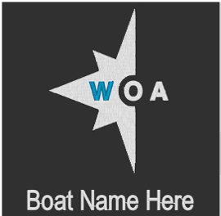

The WOA logo is embroidered direct on the shirt material. If supplied, the Boat Name will appear next to the Logo as shown here:

Item | Size (Unisex) | Colour | Quantity | Total
Classic Polo shirt UC101  (childrens sizes are available as UC103)  50% polyester  50% cotton  £11.25 ea. | XS  36 |  |  | £
 | S  38 |  |  | £
 | M  40 |  |  | £
 | L  42-44 |  |  | £
 | XL  46 |  |  | £
 | 2XL  48 |  |  | £
 | 3XL  50-52 |  |  | £
 | 4XL  54 |  |  | £
Sub total: |  |  |  | £
Postage based on No. of items:  (See table above) |  |  |  | £
Total: |  |  |  | £
Payment has been made by (delete as applicable): |  |  |  | Cheque/BACS

